**Michelle Wild**

**REQUIRED DOCUMENTS**

**1.** **Biography**

Hello everyone! My name is Michelle. I’m originally from Melbourne, Australia. I have been in Vietnam since February this year, and recently relocated from Hanoi to Hoi An. Many years ago I taught English to some of the first Vietnamese to come to Australia as refugees, and I have been interested in Vietnam ever since. Since then, I have predominantly worked in arts management, working with artists and organizing festivals all over the world. I like to travel, and I particularly like to work while I’m travelling. I’m really looking forward to meeting you all and helping you to improve your English!

**2. Photo**

**3. Copy of passport and driving license**

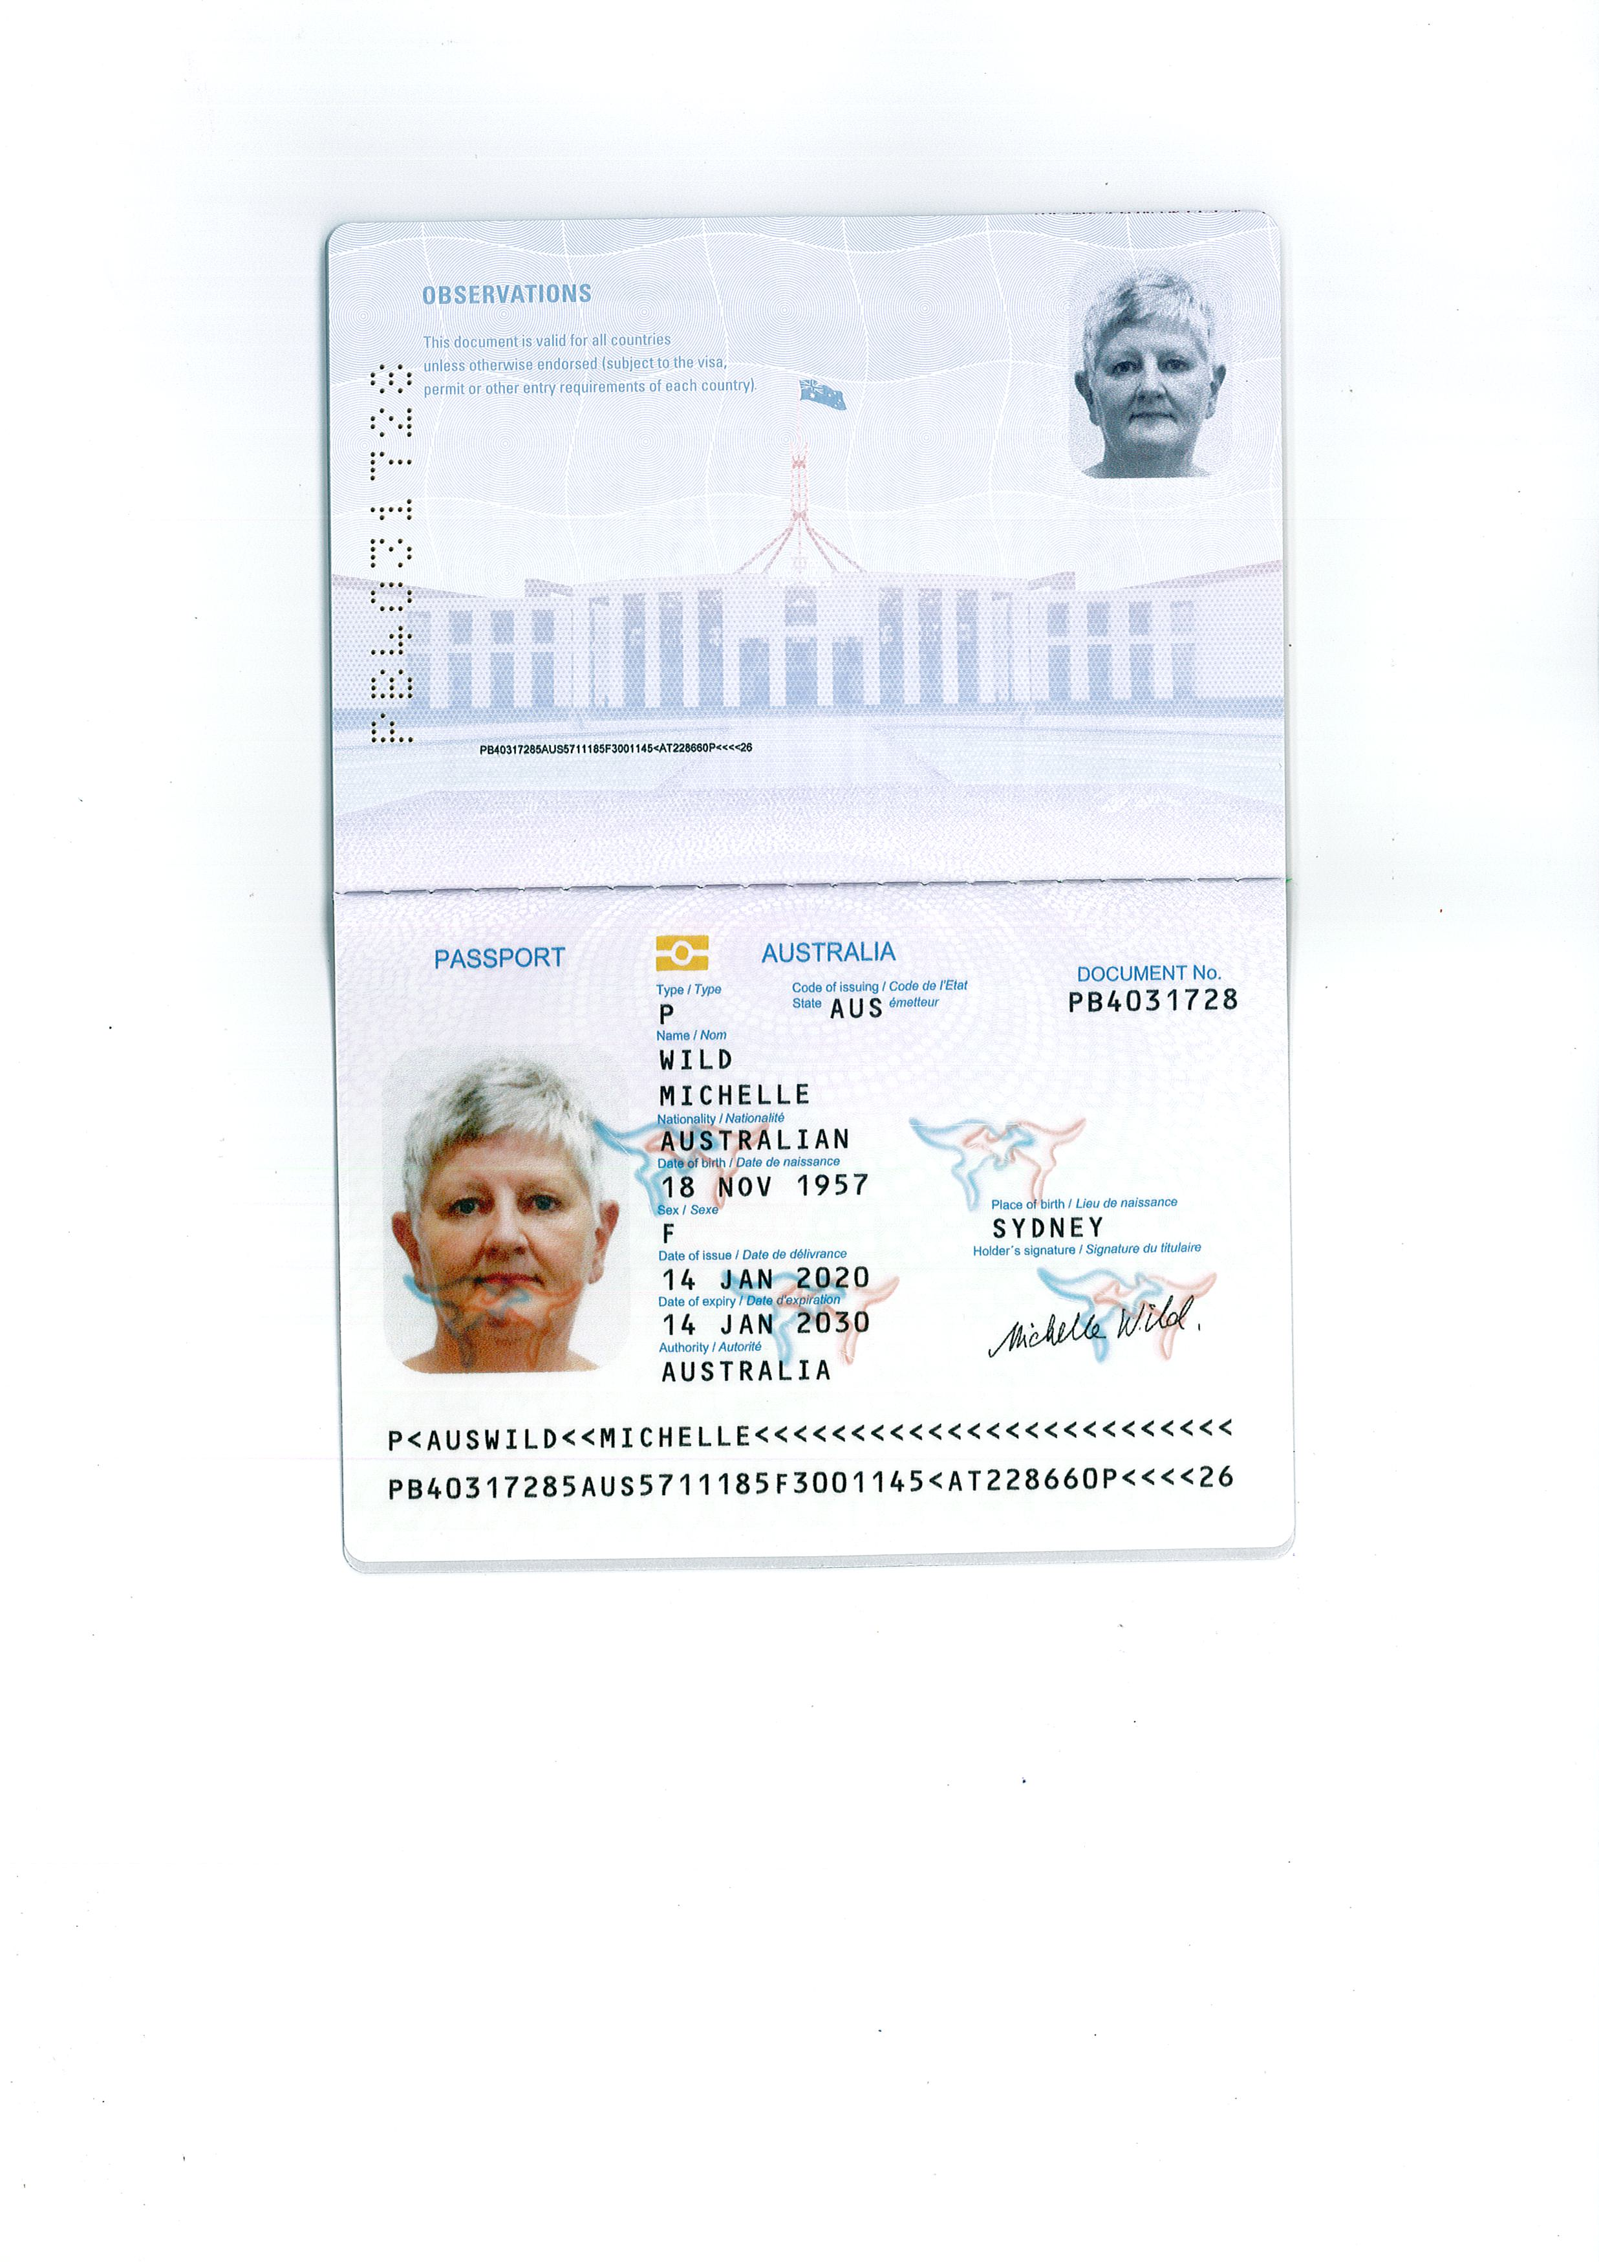

**4.**    **Code of conduct**

PDF file signed and attached.